Explosion-proof tuning fork level switch
The explosion-proof tuning fork level switch causes its vibration through the resonance of the transistor. When subjected to material damping, the amplitude sharply decreases and the frequency and phase undergo significant changes. These changes are detected by the internal electronic circuit, processed, and converted into a switch signal output.
The explosion-proof tuning fork level switch is not affected by dielectric electrical parameters, as well as factors such as turbulence, agitation, bubbles, vibration, etc. It has no moving parts and therefore does not require maintenance and adjustment. It is an ideal choice for level switches under complex working conditions.
The explosion-proof tuning fork level switch is suitable for almost all liquid media, such as liquids with explosive and non explosive hazards, corrosive liquids (acid, alkali), high viscosity liquids, etc; It is not affected by foam, vortex and gas. It is also suitable for measuring medium density solid powders or particles that can flow freely.

防爆音叉物位开关
防爆音叉物位开关是通过电晶体的谐振来引起其振动的，当受到物料阻尼作用时，振幅急剧降低且频率和相位发生明显变化，这些变化会被内部电子电路检测到，经过处理后，转换成开关信号输出。
防爆音叉物位开关不受介质电参数以及湍流、搅动、气泡、 振动等因素的影响，无活动部件，因此无需维护和调整，是复杂工况下物位开关的理想选择。
防爆音叉物位开关几乎适用于所有的液体介质，如具有爆炸性和非爆炸性危险的液体，腐蚀性液体（酸、碱）高粘度液体等；它不受泡沫、涡流、气体的影响。同时也适用于测量能自由流动的中等密度的固体粉末或颗粒。

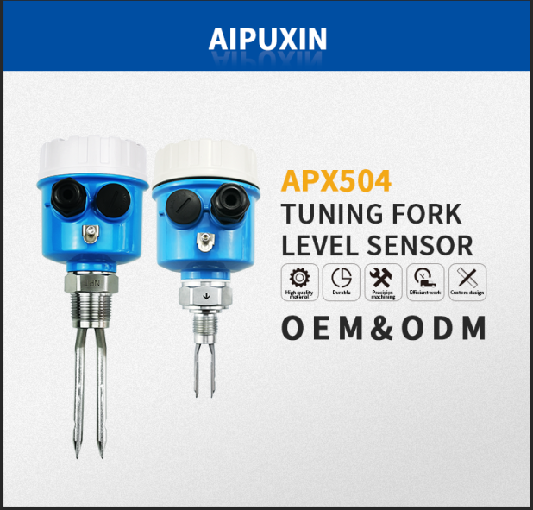
APX504
explosion-proof tuning fork level switch防爆音叉物位开关
OEM ODM定制服务

There are two types of explosion-proof tuning fork level switches to choose from, and the international universal housing can provide OEM and ODM customized services.
The explosion-proof tuning fork level switch is a type of level switch that mainly uses the resonance principle of the tuning fork to measure the level status. Its unique fork body design and inherent vibration characteristics can ensure the automatic clearing function of the tuning fork and maximize the prevention of material hanging.
The amplitude of the explosion-proof tuning fork level switch is adjustable, making it easy to measure materials of different states and densities. It is suitable for fixed-point detection, alarm or control of solid material levels in various silos and liquid levels in various containers.
防爆音叉物位开关两种叉体可选择，国际通用壳体可提供OEM、ODM定制服务。
防爆音叉物位开关是物位开关的一种，主要利用音叉谐振原理来测量物位状态，其独特的叉体设计及其固有的振动特性，能保证音叉的自动清除功能并最大限度地防止挂料。
防爆音叉物位开关振幅可调，便于测量不同状态和密度的物料，适用于各种料仓固体物料料位以及各种容器内液位的定点检测报警或控制。

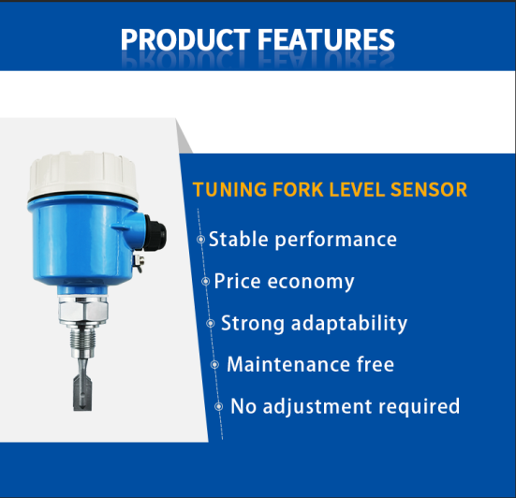
产品特点
explosion-proof tuning fork level switch防爆音叉物位开关
Stable performance性能稳定
Price economy价格经济
Strong adaptability适应性强
Maintenance free免于维护
No adjustment required不需调校
1、 Strong adaptability: The different electrical parameters and densities of the measured liquid have no impact on the measurement. Severe conditions such as scaling, agitation, turbulence, bubbles, vibration, medium viscosity, high temperature, and high pressure also have no impact on the detection.
2、 Maintenance free: As the detection process of the tuning fork limit switch is completed by electronic circuits and there are no moving parts, maintenance is not required once installed and put into operation.
3、 No need for calibration: As the detection of the tuning fork limit switch is not affected by the electrical parameters and density of the measured medium, on-site calibration is not required for any liquid being measured.
一、适应性强：被测液体不同的电参数、密度对测量均不产生影响。结垢、搅动、湍流、气泡、振动、中等粘度、高温、高压等恶劣条件对检测也无影响。
二、免于维护：由于音叉限位开关的检测过程由电子电路完成，无活动部件，所以一经安装投运便不需要维护。
三、不需调校：由于音叉限位开关的检测不受被测介质电参数及密度的影响，所以无论测量何种液体都不需现场调校。

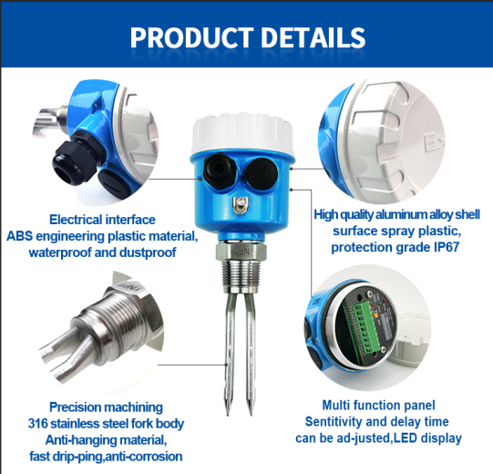
product details
Electrical interface ABS engineering plastic material, waterproof and dustproof
High quality aluminum alloy shell surface sprayed with plastic, with a protection level of IP67
Precision machined 316 stainless steel fork body anti hanging material, fast dripping, corrosion resistant
Multifunctional panel, adjustable sensitivity and delay time, LED indication
产品详情
电气接口ABS工程塑料材料，防水防尘
优质铝合金外壳表面喷塑，防护等级IP67
精密加工316不锈钢叉体防挂材料，滴水快，耐腐蚀
多功能面板，灵敏度和延迟时间可调，LED指示
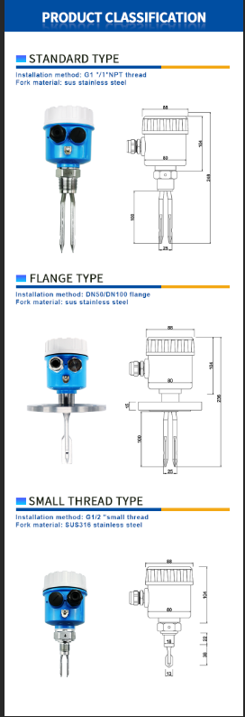
Product classification
Standard type
Installation method: G1 ''/1 '' NPT thread,
Fork material: SUS stainless steel
Flange type
Installation method: DN 50/DN100 flange,
Fork material: SUS stainless steel
Small thread type
Installation method: G1/2 '' small thread
Fork material: SUS316 stainless steel产品分类
标准型
安装方式：G1’’/1’’NPT螺纹，
叉体材质：SUS不锈钢
法兰型
安装方式：DN 50/DN100 法兰，
叉体材质：SUS不锈钢
小螺纹型
安装方法：G1/2’’小螺纹
叉体材质：SUS316不锈钢

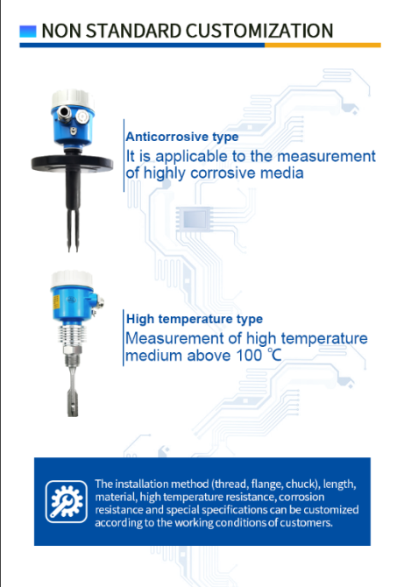
Non standard customization
Anticorrosive type
Suitable for measuring highly corrosive media
High temperature type
Measurement of high-temperature medium above 100 ℃
The installation method (thread, flange, chuck), length, material, high temperature resistance, corrosion resistance, and special specifications can be customized according to the customer's working conditions.非标定制
防腐型
适用于高腐蚀性介质的测量
高温型
100℃以上高温介质测量

安装方法（螺纹、法兰、卡盘）、长度、材料、耐高温性、耐腐蚀性和特殊规格可根据客户的工作条件定制。
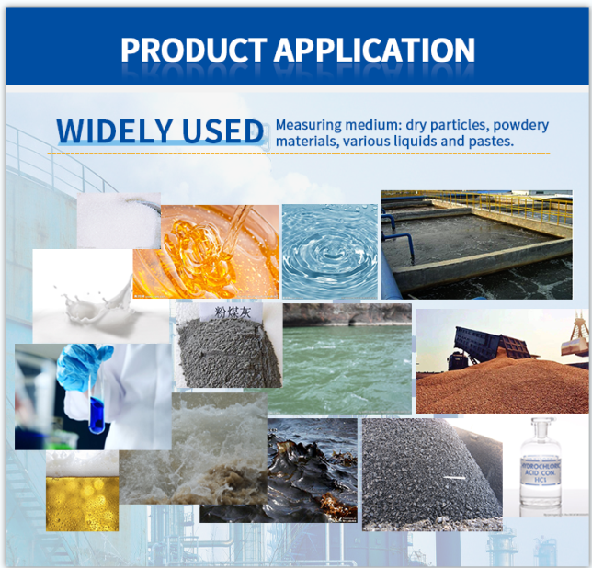
application产品应用
Widely used
Measurement medium: Dry particles, powdered materials, and various liquids and slurries.应用广泛
测量介质：干燥颗粒、粉状物料及各种液体、浆体。

The amplitude of the explosion-proof tuning fork level switch is adjustable, making it easy to measure materials of different states and densities. It is suitable for fixed-point detection, alarm or control of solid material levels in various silos and liquid levels in various containers.
Solid materials: fly ash, cement, stone powder, plastic particles, salt, sugar
Liquid media: water, acid, alkali, mud, fuel, oil, milk, alcohol, beverages
防爆音叉物位开关振幅可调，便于测量不同状态和密度的物料，适用于各种料仓固体物料料位以及各种容器内液位的定点检测报警或控制。
固体物料：粉煤灰、水泥、石粉、塑料颗粒、盐、糖
液体介质：水、酸、碱、泥浆、燃料、油类、牛奶、酒类、饮料
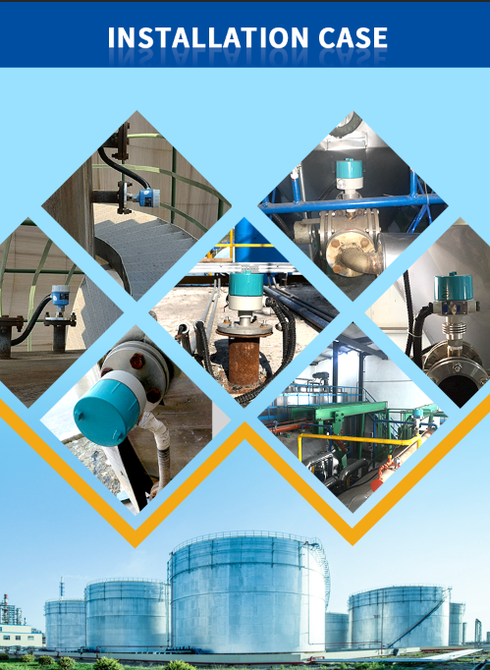
安装案例

Explosion proof tuning fork level switches are widely used in petroleum, chemical, light industry, food, water treatment, building materials, and environmental protection industries, providing comprehensive solutions for various industries.
防爆音叉物位开关广泛应用于石油、化工、轻工、食品、水处理、建材、环保行业，为各行各业提供完善解决方案。

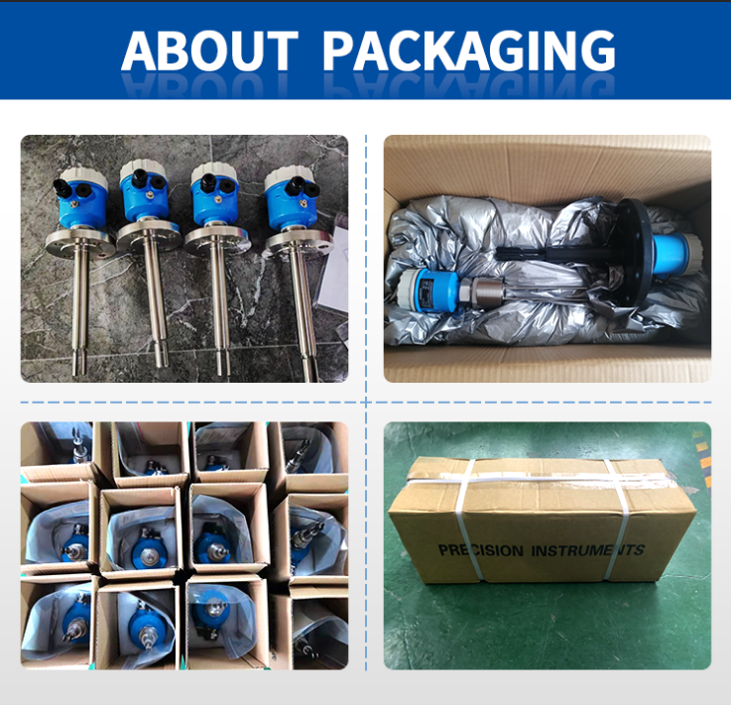
关于包装

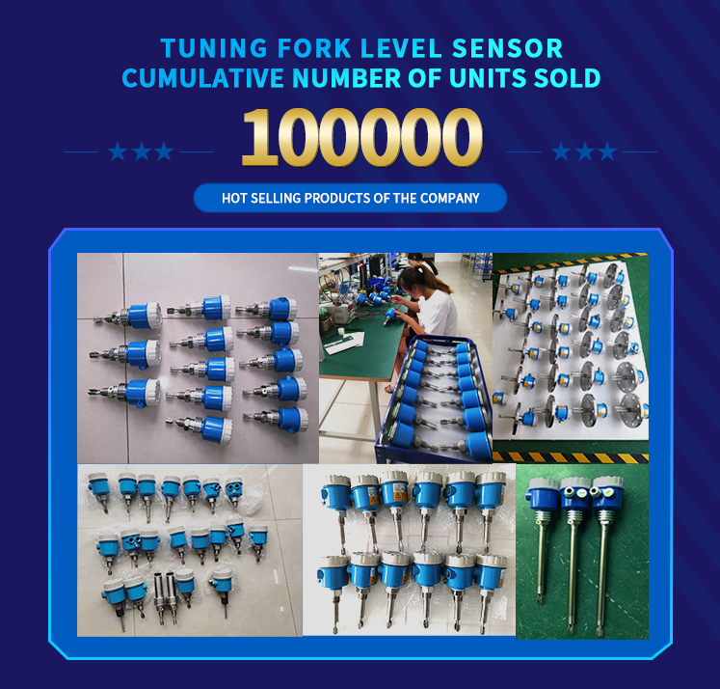
Accumulated sold quantity of explosion-proof tuning fork level switches
Company's best-selling products
防爆音叉物位开关累计售出数量
公司热销产品
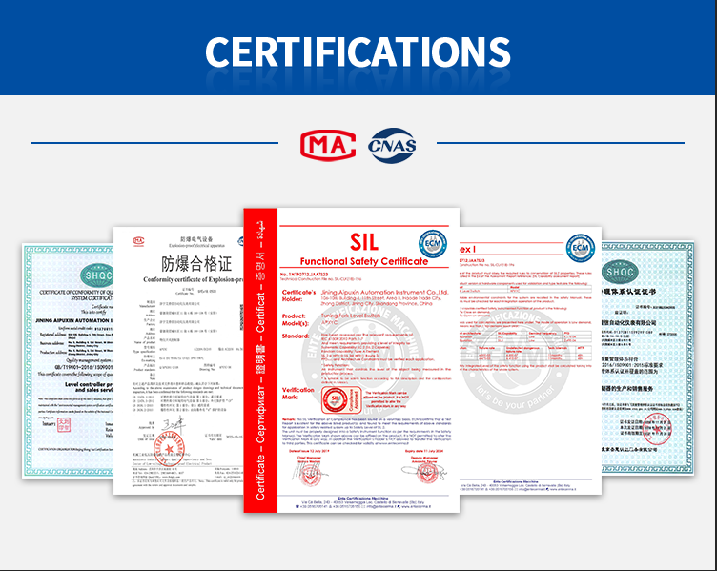
证书
12个月保修期；终身免维护

